**ASSIGNMENT-4**

|  |  |
| --- | --- |
| Date | 24 October 2022 |
| TeamID | PNT2022TMID06193 |
| Name | A Sathiyaseelan |
| MaximumMarks | 2Marks |

# Question1:

Write code and connections in work for ultrasonic sensor.Whenever distance is lessthan 100cms send"alert" to ibm cloud and display in device recent events.

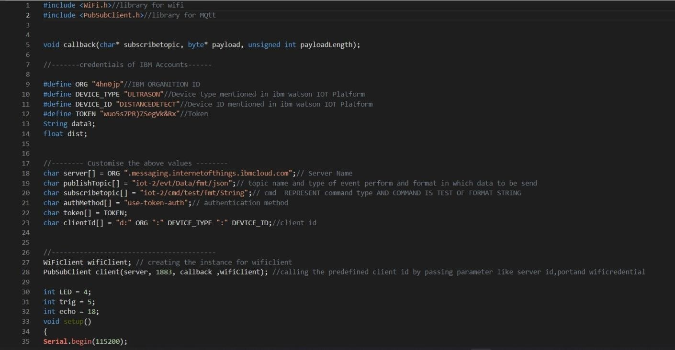**CODE**:

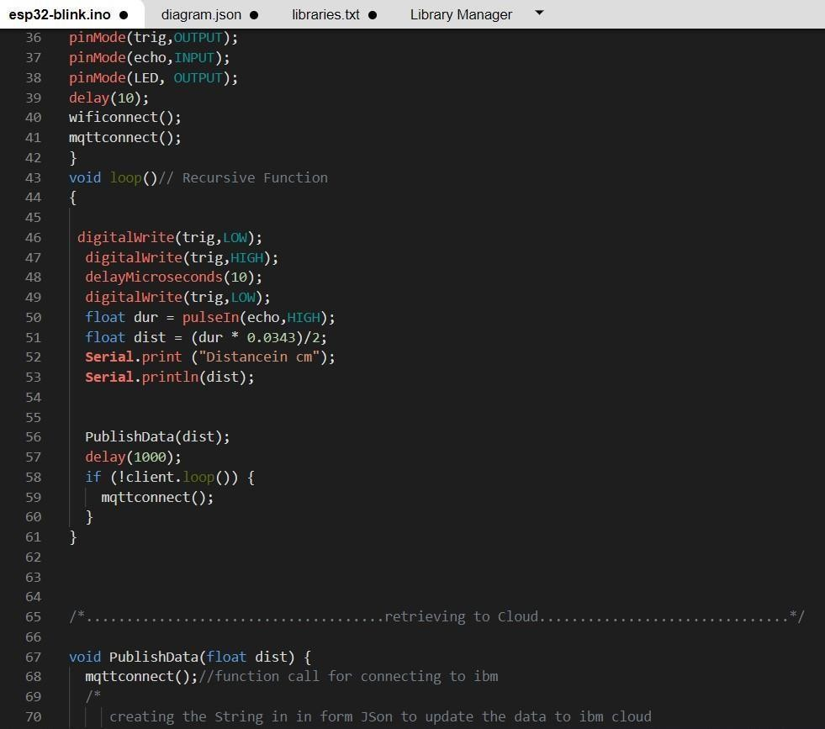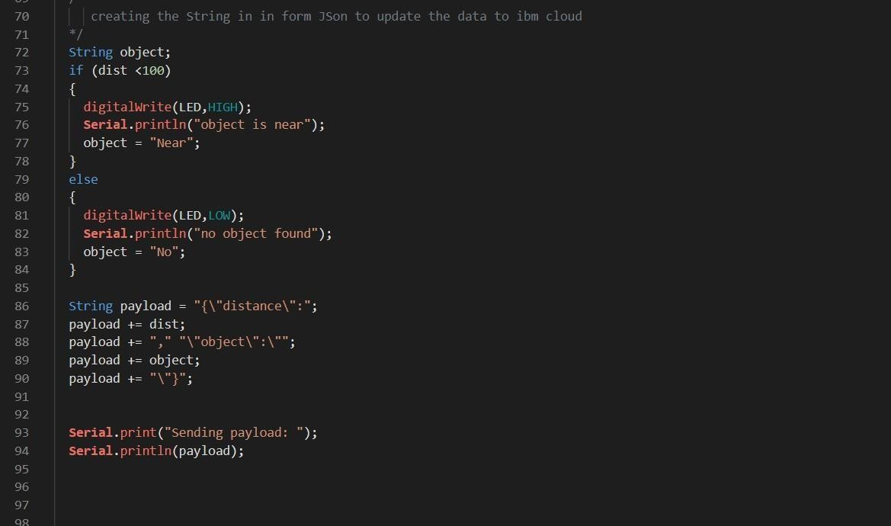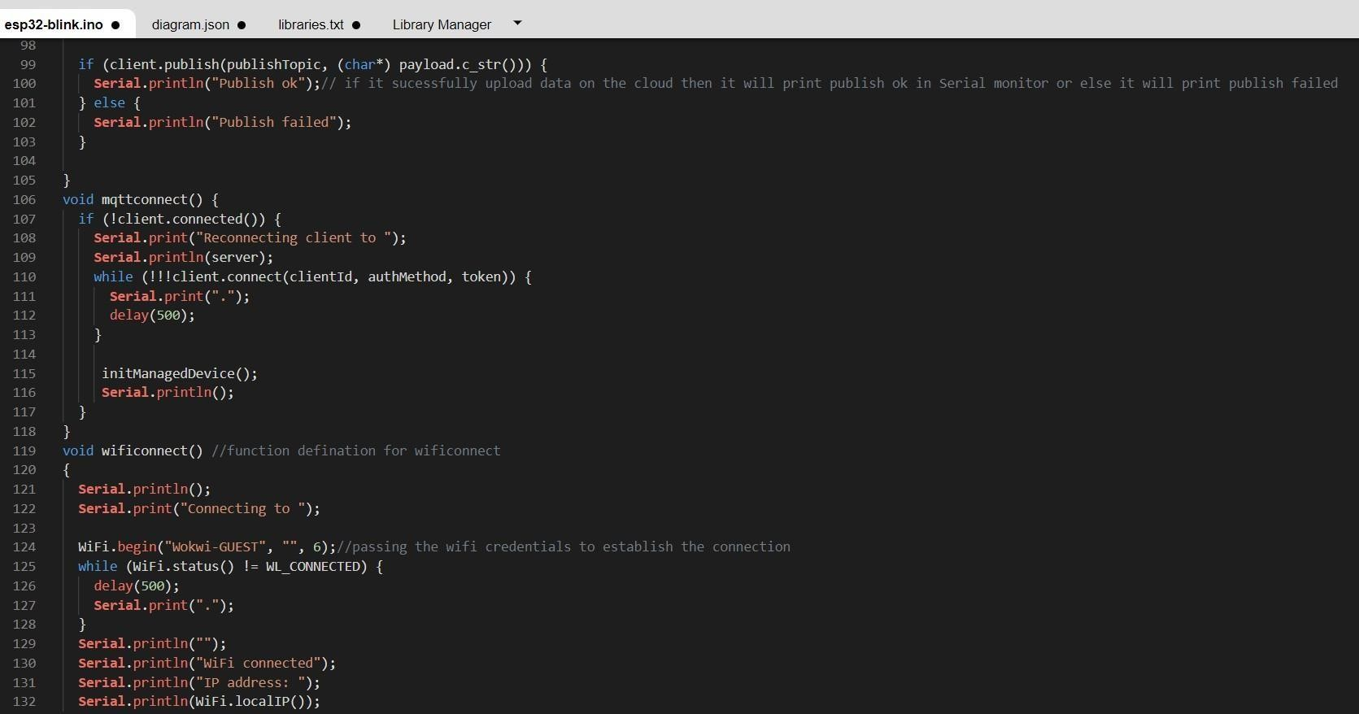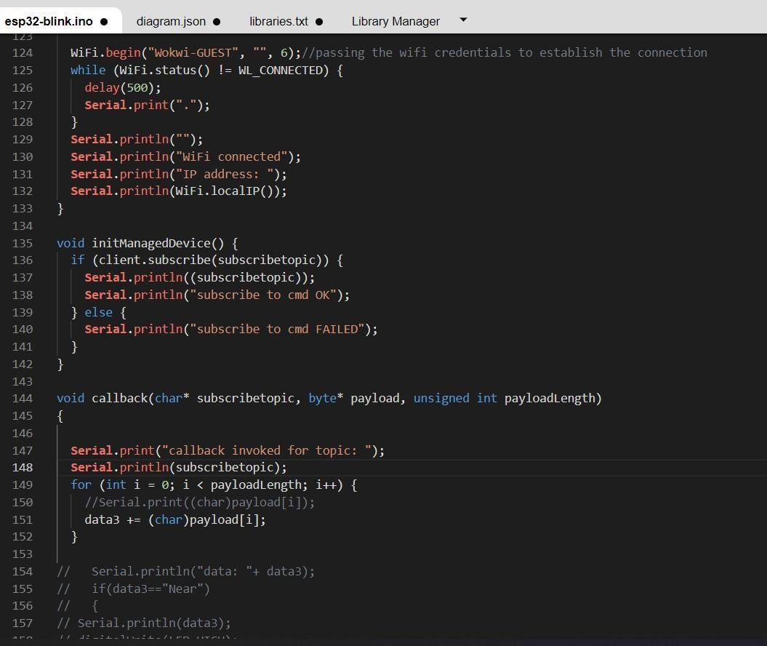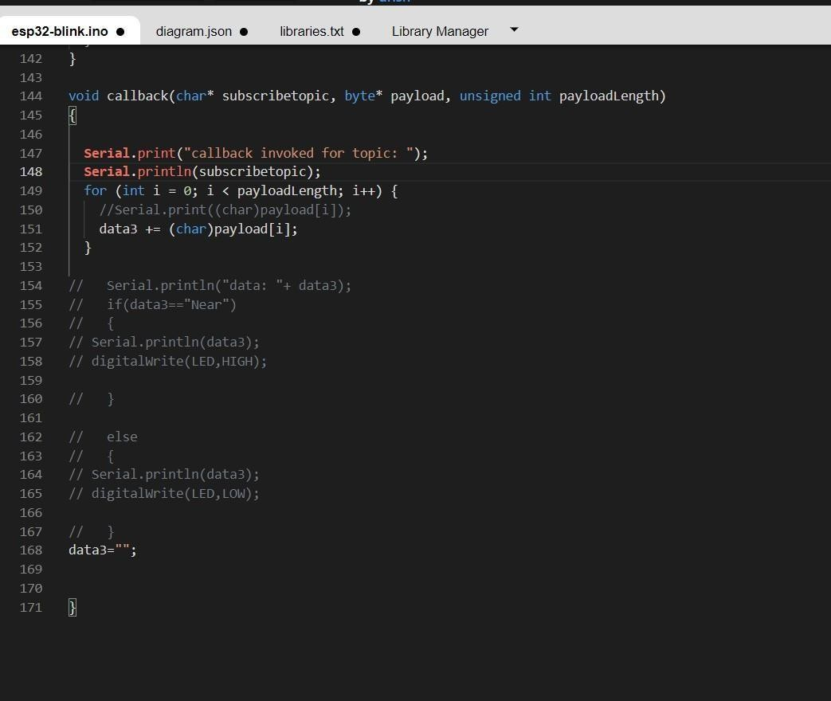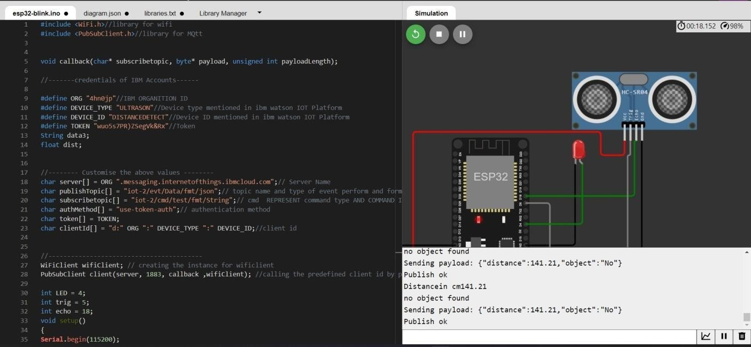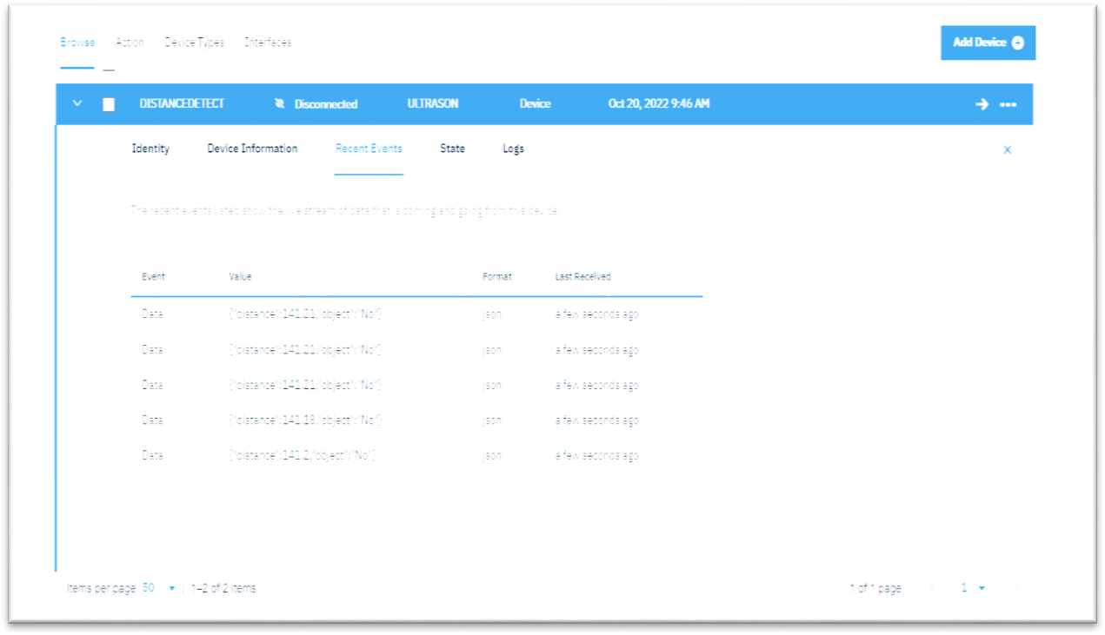

# OUTPUT:

Data send to the IBMcloud device when the objectics far

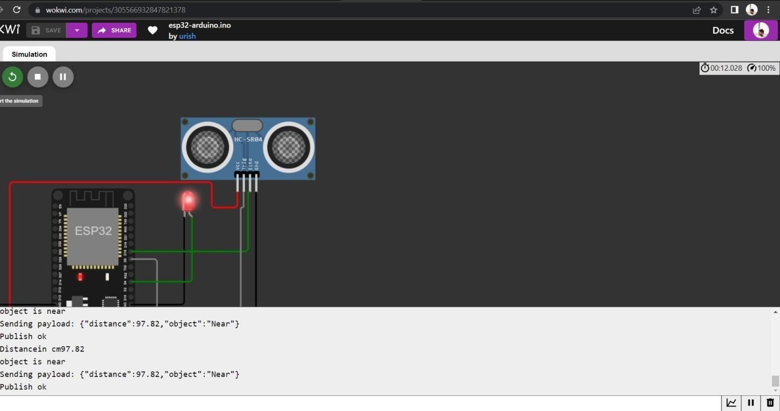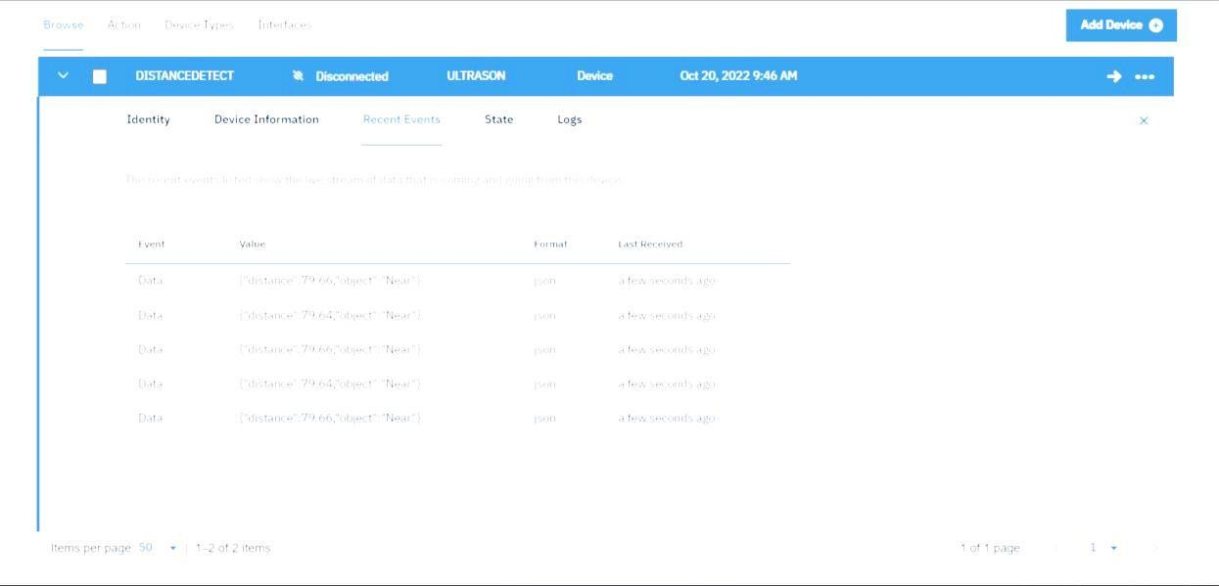

Data sent to the IBMCloud Device when the objectis near

# When objectics near to the ultrasonicsensor